**STOKE & HURLESTON PARISH COUNCIL**

ANNUAL PARISH COUNCIL MEETING

To be held at the Nantwich Vets, Hurleston

Not to start before 7.40pm 16th May 2022

**Clerk to the Parish Council:** Helen Exley, Daisy Bank Farm, off Top Farm Lane, Cholmondeston, Cheshire CW7 4DR 01270 528768

E mail: [clerk@stokeandhurleston-pc.gov.uk](mailto:clerk@stokeandhurleston-pc.gov.uk)

All members of the public are welcome to attend.

AGENDA

1. Apologies
2. Election of Chairman
3. Election of Vice Chairman
4. Election of Responsible Financial Officer
5. Parish Councillor Vacancy
6. Public Forum

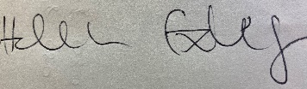

Helen Exley

Clerk  - Stoke and Hurleston Parish Council

11th May 2022