Stoke & Hurleston Parish Council

Clerk: Mrs Helen Exley Daisy Bank Farm, Off Top Farm Lane, Cholmondeston. CW7 4DR

Tel: (01270) 528768 clerk@stokeandhurleston-pc.gov.uk
www.stokeandhurleston-pc.gov.uk
Dear Sir or Madam,
You are hereby summoned to attend a meeting of the above mentioned Council, to be held on Monday 6th September 2021. To be held at the Vets meeting rooms, Hurleston. Commencement of meeting not before 7:30pm. All members of the press and public are welcome to attend.
.
Agenda for Quarterly Council Meeting
- Apologies
- Declaration of Councillors Interests – Members to declare any interests under the following categories: - Pecuniary interests, outside body interests, Family, friend or close associate’s interests.
- Approve Minutes of last meeting & vote for acceptance – Matters arising and vote for acceptance of Annual Parish Meeting, Annual Parish Council Meeting and Quarterly Meeting from 17/05/21

- Open Forum (15 minutes maximum).

- Borough Councillor report- Cllr Sarah Pochin to update SHPC on current issues within CEC
- Highways – To review ongoing issues and current ones to include:-
- Update on CEC outstanding issues – Closure of A51 at Wardle for slope stabilisation repairs and impact on diverted traffic through the Parish
- Matrix signs – MK to update
- Traffic Survey A51 update – see appendix

- Lengthsman duties update –
- To review any outstanding and current issues.
- Dog Bins - update on recent dispensers & signage & new lock

- Parish Council notice board –
- Planning requirements and purchase of new board.

- Clerk’s Report. –
- Recent correspondence.
- Update on Website and usage and review of current format.

- Planning Matters –
Current:-
21/3338N 19 Old Chester Court Barbridge, CW5 6AY – single storey dining room extension to back of house
Past:-
21/2505N – Stoke House, Old Chester Road CW5 6AY – single storey extension to rear/side – approved with conditions
21/1536N – Mill House, Old Chester Rd, Barbridge, CW5 6AY. 2 storey side extension. Approved with conditions
21/0580N – Park Farm, Chester Road Hurleston. Use of existing goods access as overflow for vehicle exit. – undecided

- Cheshire East Governance issues and Boundary changes – Update from VP and MK on recent CEC meeting 31/08/21

- Draft Sustainable urban Drainage Systems Supplementary Planning Document (SuDS SPD) – to discuss and review with reference to ongoing consultation. https://cheshireeastconsult.objective.co.uk/portal/planning/spd/

- Cheshire East Bus Service Improvement Plan Towns & Parish Council Engagement – JD to update on recent correspondence with CEC

- Homelessness and Rough Sleeping Strategy 2021-2025 – consultation. JD & MK to feedback to PC regarding findings on recent consultation.

- Review of current Standing Orders - Councillors to have reviewed current Standing Orders and review any amendments and additions for re-adoption .

- Payment of Accounts & Financial Matters –
Clerk’s fees, lengthsman’s fees, Meeting room fees, Dog Dispenser bags

- Items for Next Meeting agenda

- Dates of next meeting
6th December

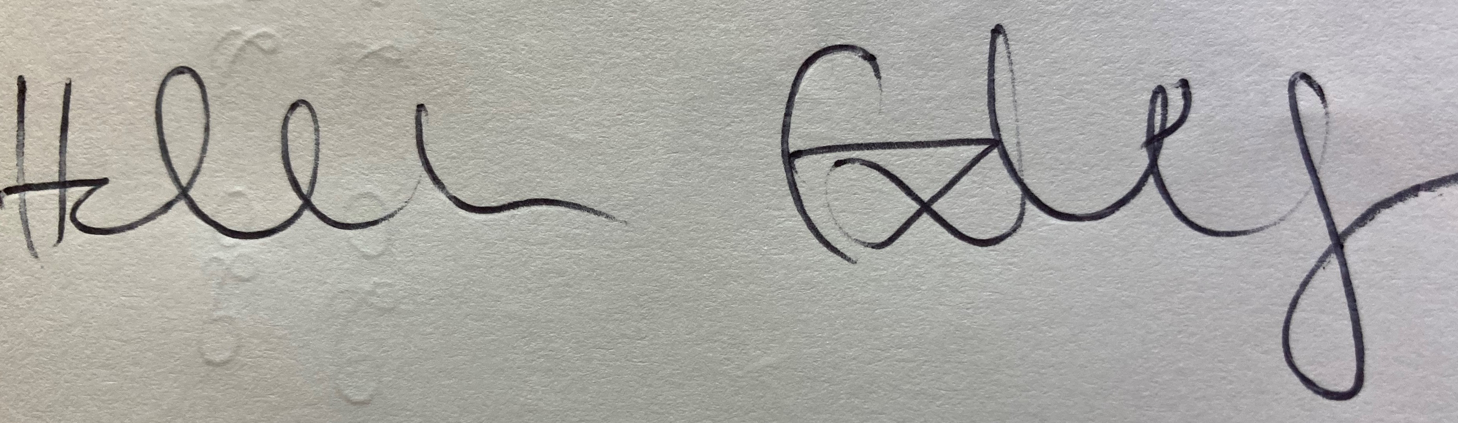 31/08/21
Clerk – Stoke & Hurleston Parish Council

Appendix – Agenda point 6.3

From:Val Kosh <valandmike4@me.com>
Sent: 27 July 2021 16:12
To: Valerie Pickford <Valerie.Pickford@outlook.com>
Cc: CHRISTINE BOWEN <christine.bowen5@btinternet.com>; Robert Darlington <oaklands@uwclub.net>; john doherty <john747doherty@hotmail.co.uk>; clerk@stokeandhurleston-pc.gov.uk
Subject: Re: [OFFICIAL] FW: 1850-WTR A51 ATC Surveys June 2021 Results

Good afternoon everyone,
Ah the rain!!!
Thanks John for your summary of the traffic survey results. I’ve had a scan of the results myself and found them interesting but probably confirm much of what we believe is the situation with the traffic.
Barbridge is site 3 , site 2 is the approach to Calveley and site 1 is in central Alpraham. While in some respects we are only interested in site 3 some of the other data could give us some clues about traffic flow etc.

So Barbridge. You might have seen the rubber strips across the road near the bus stops on the Nantwich side of the village. We had requested they be sited much closer to the restrictions signs by Verona. From observations if vehicles are going to slow down they often do so only when they see they are approaching the village and junctions and this might well have had an impact on the results.

Speed northbound
7 day average speed 39 mph but 32.9% of vehicles were travelling over the speed limit and 9%were at the limit where police would prosecute ie 46mph.

Speed southbound
7 day average speed 46 mph with 87.8% travelling over the speed limit 42.4% were at the limit were police would prosecute, ie 46mph.
Averaged out for north and southbound, the 7 day average shows average speed of 42.5 with 65% travelling over the limit, while 25% could be liable to prosecution
Clearly the southbound speeding is a considerable issue but still 1/3 of northbound were over the speed limit even as they approached the village well past the restriction signs.

Traffic volume
Northbound weekday average 6547, 7 day average 6161, weeks total = 43,127
Southbound weekday average 6447, 7 day average 6232,weeks total = 43,627
Combined weekday average 12,994, 7 day average 12,393 weeks total= 86754

Looking at traffic spread across the day week etc some familiar patterns arise.
Northbound there is a surge around 05.30am then about 07.00am. Shift patterns at Boughey for example might explain some of this. The flow remains fairly constant all day until dropping off after 19.00pm.
Northbound traffic peaks on Friday afternoons in addition to the early day peaks and again on Saturday morning.
Southbound builds up Friday pm and again peaks late Sunday afternoon( on return from the seaside!)

If we compare our results with the other two sites some inferences might be drawn.
Looking at our northbound daily average of 6547 vehicles by the time that traffic reaches Calveley the figure is 5810 ie 737 less in about a mile!!
Weekly total northbound is 43127, at Calvaley it’s 38658 Ie 4469 less in a mile?

Southbound is equally interesting with the daily average picking up 711 extra vehicles between Calveley and Barbridge thats per day!!!

John hits the nail on the head when he points to the industrial complex of Boughey, Rawlinson and NIck Brookes. The situation will worsen as the Wardle Airfield site builds and there is more land for sale near Rawlison being marketed as ideal for warehouse and distribution.

A meeting with our CE councillor would be a good idea. I will try and pick up on views from contacts in A51 group before any meeting.

