Stoke & Hurleston Parish Council

Clerk: Mrs Helen Exley Daisy Bank Farm, Off Top Farm Lane, Cholmondeston. CW7 4DR

Tel: (01270) 528768 clerk@stokeandhurleston-pc.gov.uk
www.stokeandhurleston-pc.gov.uk
Dear Sir or Madam,
You are hereby summoned to attend a meeting of the above mentioned Council, to be held on Monday 6th December 2021. To be held at the Vets meeting rooms, Hurleston. Commencement of meeting not before 7:30pm. All members of the press and public are welcome to attend.
.

Agenda for Quarterly Council Meeting
A minute’s silence to be held for Cllr Ken Hough
- Apologies
- Declaration of Councillors Interests – Members to declare any interests under the following categories: - Pecuniary interests, outside body interests, Family, friend or close associate’s interests.
- Approve Minutes of last meeting & vote for acceptance – Matters arising and vote for acceptance of the Quarterly Meeting from 06/09/21

- Open Forum (15 minutes maximum).

- Councillor Vacancy – The parish of Stoke.- Co option of candidate

- Borough Councillor report- Cllr Sarah Pochin to update SHPC on current issues within CEC
- Highways – To review ongoing issues and current ones to include:-
- Update on CEC outstanding issues –Update on road closure of A51 at Wardle for slope stabilisation repairs and impact on diverted traffic through the Parish
- Matrix signs – MK to update
- Parishes on A51 – meeting update – SP
- Update on meeting with SP and MK on outstanding issues around the Parish -
Hedge at bridge 100/Tree at Stoke Manor/Cutting of Hedge on A51 to reveal sign/Right hand turn sign.

- Lengthsman duties update –
- To review any outstanding and current issues.
- Dog poo marking with spray
- Bin stickers

- Parish Council notice board –
- Review of purchase of new board.

- Clerk’s Report. –
- Recent correspondence.

- Planning Matters –
Current:-
21/5277N – Dog exercise area, Chester Road, Hurleston
Past:-
21/4643N – 3 Canal Cottages, replace outriggers – undecided.
21/3338N 19 Old Chester Court Barbridge, CW5 6AY – single storey dining room extension to back of house – Approved with conditions
21/0580N – Park Farm, Chester Road Hurleston. Use of existing goods access as overflow for vehicle exit. – undecided -

- Cheshire East Governance issues and Boundary changes – PC Comments submitted and survey completed on behalf of SHPC 22/11/21

- Police & Crime plan 2021-2024 – review of recent plan that has been published

- Review Of Cheshire East Council Taxi policy – Councillors to discuss policy notification.

- CEC Bus service review - update from JD

- Free trees for planting projects – Councillors to review https://eforests.co.uk/freetrees

- Review of Revised Standing Orders – Now circulated to Councillors

- Precept setting for 2022/2023 – Budget forecast

- Payment of Accounts & Financial Matters –
- Update on bank mandate – new signatories required.
- Clerk’s fees, lengthsman’s fees, Meeting room fees, Noticeboard costs, Cheque to St Lukes - donation for the tree.

- Items for Next Meeting agenda
- Dates of 2022 meetings
7th March
16th May – to include Annual Meeting
5th September
5th December

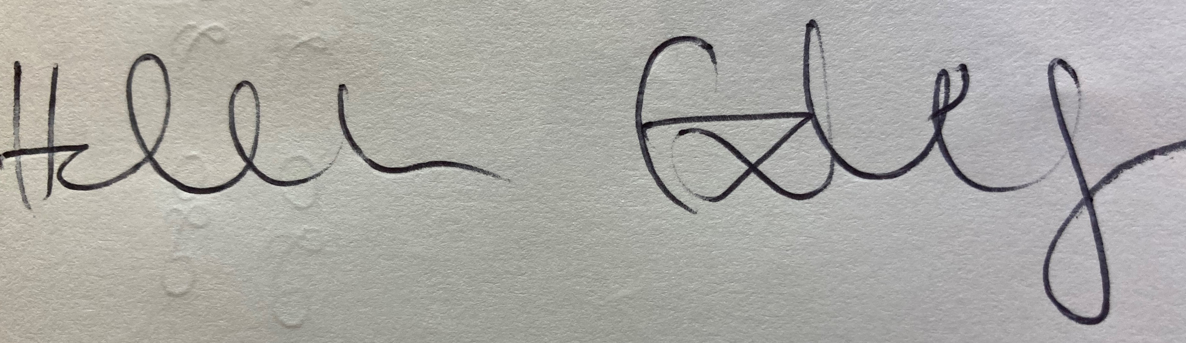 30/11/21
Clerk – Stoke & Hurleston Parish Council

