Stoke & Hurleston Parish Council

Clerk: Mrs Helen Exley Daisy Bank Farm, Off Top Farm Lane, Cholmondeston. CW7 4DR

Tel: (01270) 528768 clerk@stokeandhurleston-pc.gov.uk
www.stokeandhurleston-pc.gov.uk
Dear Sir or Madam,
You are hereby summoned to attend a meeting of the above mentioned Council, to be held on Monday 17th May 2021 . To be held at the Vets meeting rooms, Hurleston. Commencement of meeting not before 7:45pm. All members of the press and public are welcome to attend.
.
Agenda for Quarterly Council Meeting
- Apologies
- Declaration of Councillors Interests – Members to declare any interests under the following categories: - Pecuniary interests, outside body interests, Family, friend or close associate’s interests.
- Approve Minutes of last meeting & vote for acceptance – Matters arising and vote for acceptance from 08/03/21

- Open Forum (15 minutes maximum).

- Borough Councillor report- Cllr Sarah Pochin to update SHPC on current issues within CEC
- Highways – To review ongoing issues and current ones to include:-
- Update on CEC outstanding issues
- Matrix signs – MK to update
- Traffic Survey A51 update

- Lengthsman duties update –
- To review any outstanding and current issues.
- Dog Bins - ongoing issues with dog fouling in the parish

- Parish Council notice board –
- Update on planning requirement for the siting of the board .

- Clerk’s Report. –
- Recent correspondence.

- Planning Matters –
Current:-
21/1536N – Mill House, Old Chester Rd, Barbridge, CW5 6AY. 2 storey side extension.
Past:-
21/0580N – Park Farm, Chester Road Hurleston. Use of existing goods access as overflow for vehicle exit. – undecided

- Cheshire East Governance issues and Boundary changes – to discuss the recent formal consultation on draft proposals around boundary changes and parish matters.

- Review of current Standing Orders - to update as required.

- Parish Insurance – annual payment of insurance

- Clerk & Lengthman’s payments - to review current level of payments.

- Payment of Accounts & Financial Matters –
- Clerk’s fees & expenses, lengthsman’s fees, Meeting room fees, Audit Fees

- Annual Audit – to approve & sign off Annual Audit for 2020/21 parish finances.

- Items for Next Meeting agenda

- Dates of next meetings
6th September
6th December

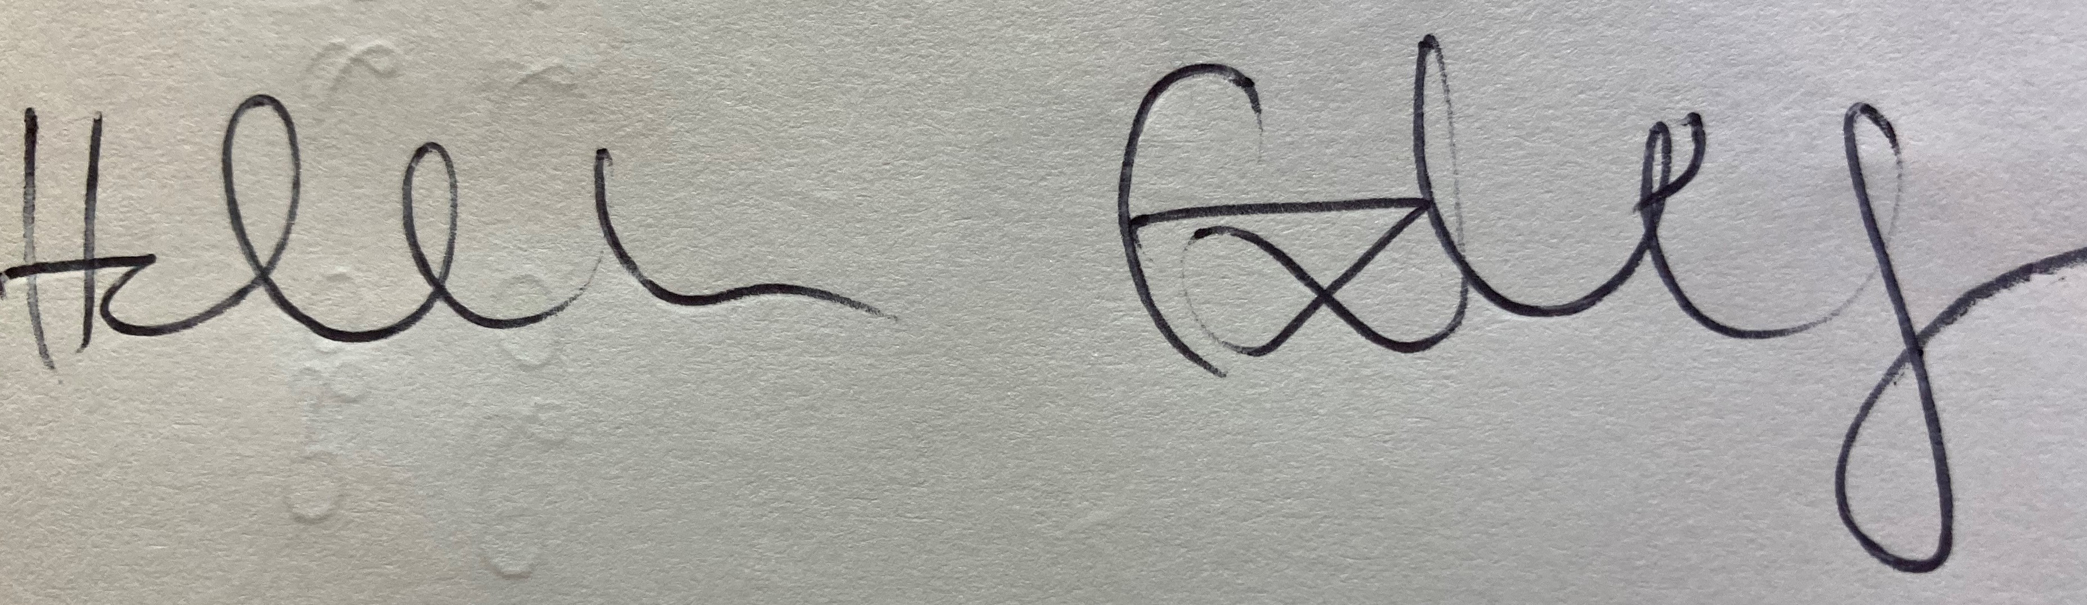
Clerk – Stoke & Hurleston Parish Council

