Stoke & Hurleston Parish Council

Clerk: Mrs Helen Exley Daisy Bank Farm, Off Top Farm Lane, Cholmondeston. CW7 4DR

Tel: (01270) 528768 clerk@stokeandhurleston-pc.gov.uk
www.stokeandhurleston-pc.gov.uk
Dear Sir or Madam,
You are hereby summoned to attend a meeting of the above mentioned Council, to be held on Monday 7th March 2022. To be held at the Vets meeting rooms, Hurleston. Commencement of meeting not before 7:30pm. All members of the press and public are welcome to attend.
.

Agenda for Quarterly Council Meeting

- Apologies
- Declaration of Councillors Interests – Members to declare any interests under the following categories: - Pecuniary interests, outside body interests, Family, friend or close associate’s interests.
- Approve Minutes of last meeting & vote for acceptance – Matters arising and vote for acceptance of the Quarterly Meeting from 06/12/21

- Open Forum (15 minutes maximum).

- Borough Councillor report- Cllr Sarah Pochin to update SHPC on current issues within CEC
- Highways – To review ongoing issues and current ones to include:-
- Update on CEC - outstanding issues in the Parish
- Meeting update held on the 2nd March with SP to include S106 monies and expenditure
- Hedge at bridge 100 – now completed
- Tree at Stoke Manor/Cutting of Hedge on A51.

- Lengthsman duties update –
- To review any outstanding and current issues.
- Dog poo marking with spray

- Parish Council notice board –
- Siting of new board - update.

- Clerk’s Report. – Recent Correspondence, CHALC Course
- Website – Improvement around the current site and update
- Defribrillator Training – refresher course to be organised by CB
- Local Community Champion Recognition – consideration for the addition of this scheme into the parish

- Planning Matters –
Current:-
21/6473N – HollyTree Cottage, Mill Pool Lane, CW5 6AU – Kitchen Extension & New Garage
21/6359N – Stoke Hall Farm, Stoke Hall Lane, CW5 6AS – Demolition of Barns and conversion of Agricultural buildings to create 7 new dwellings
Past:-
21/5277N – Dog exercise area, Chester Road, Hurleston – approved with conditions
21/4643N – 3 Canal Cottages, replace outriggers – undecided.
21/0580N – Park Farm, Chester Road Hurleston. Use of existing goods access as overflow for vehicle exit. – undecided

- Payment of Accounts & Financial Matters –
- Update on bank mandates
- Clerk’s fees, lengthsman’s fees, Meeting room fees, Annual website costs, Clerks Expenses (donation for the tree collection & payment of Dog Bin bags).

- Items for Next Meeting agenda
- Date of next 2022 meetings

16th May – to include Annual Meeting
5th September
5th December

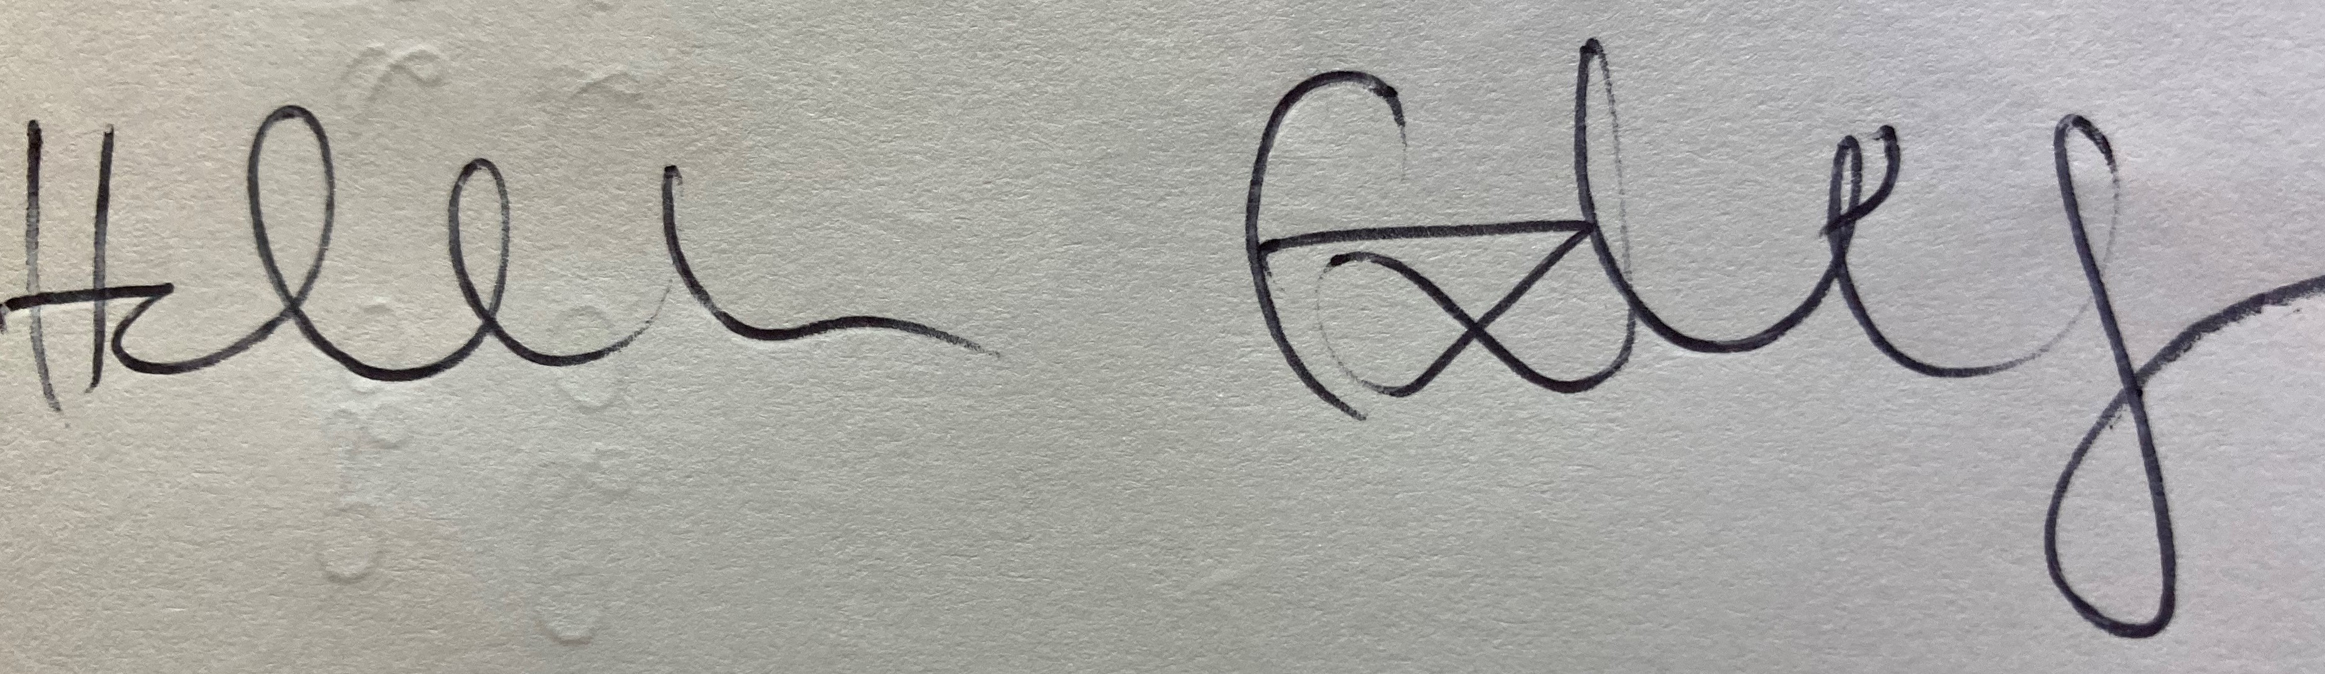 01/03/22
Clerk – Stoke & Hurleston Parish Council

